**Layout Design Process**

Member: Pham The Phi, Tong Dam Thang Long

In the first scrum, we designed three layouts in wireframe diagram, which are Homepage of Guess, Student, Marketing Coordinator and Marketing Manager, Login and Update Profile. Besides, I have already designed it in responsive design, three main devices, which are PC, Tablet and Mobile. The tool we used to create layout is Figma. And here the things:

**Homepage (Guest)**

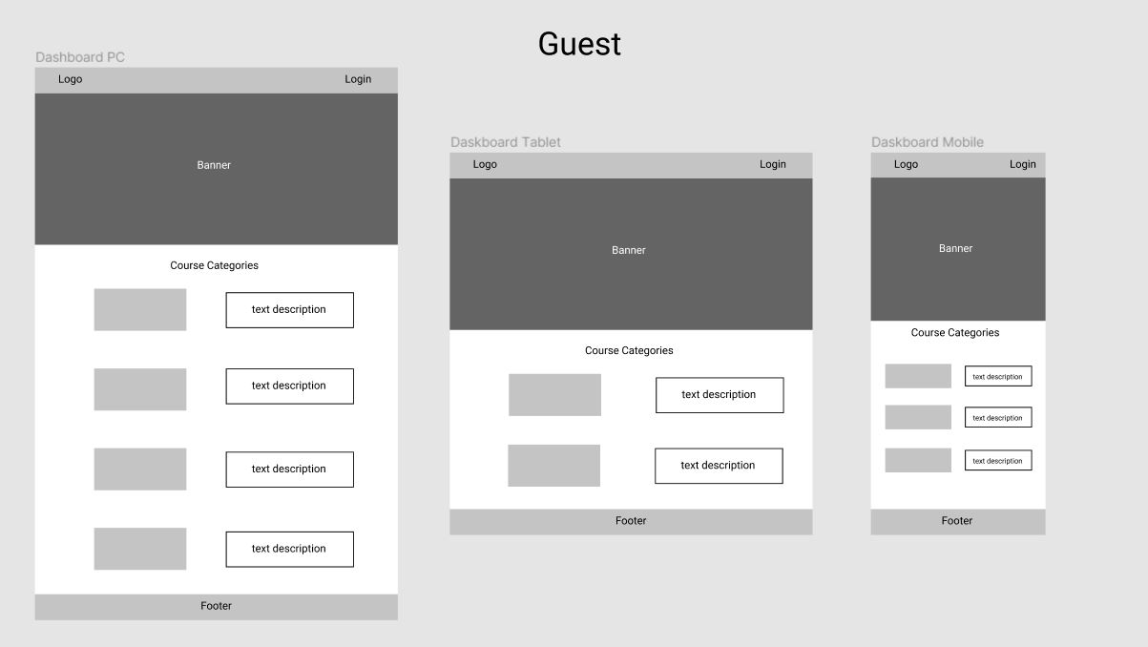

**HomePage (Student)**

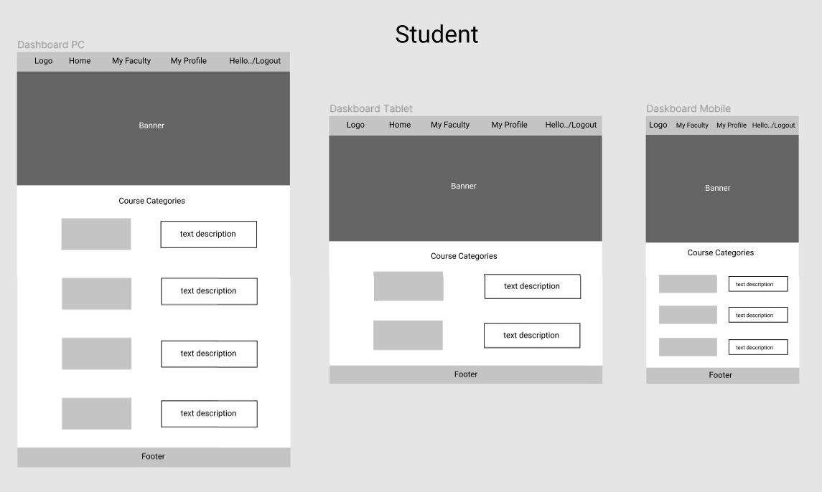

**HomePage (Coordinator)**

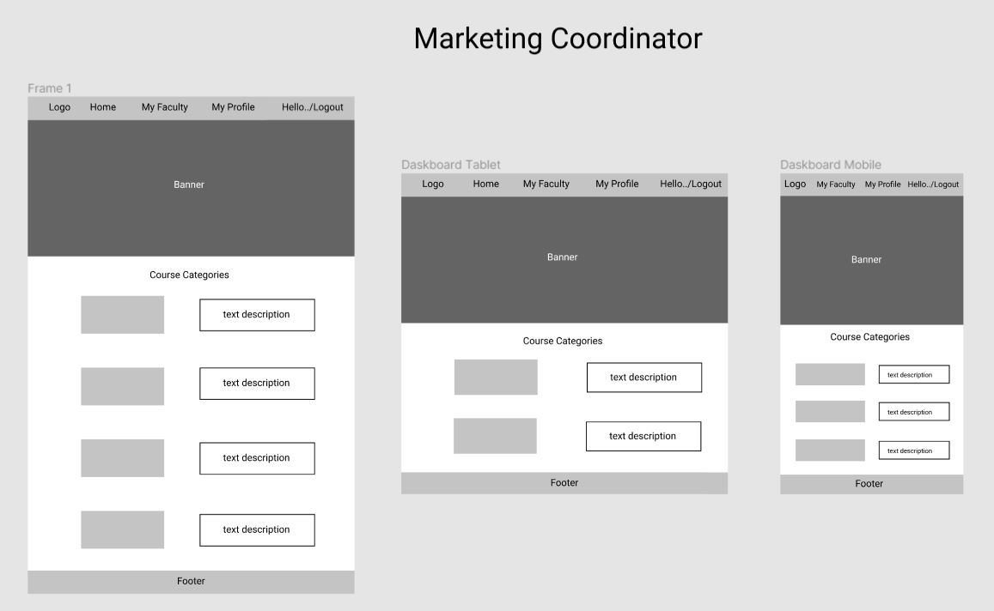

**Homepage (Manager)**

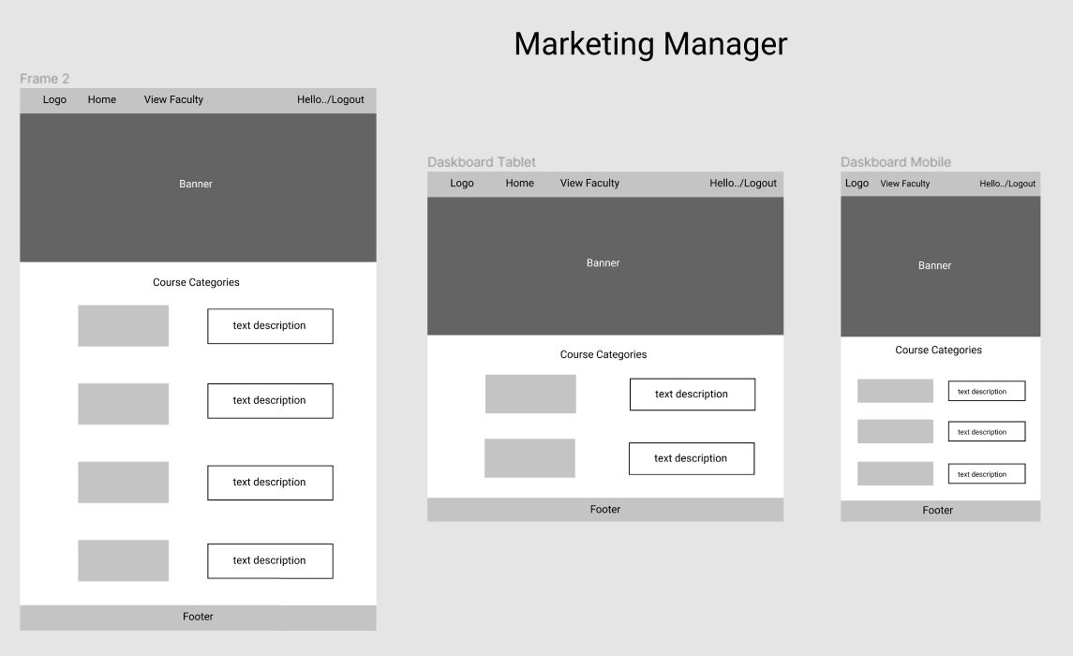

**Login**

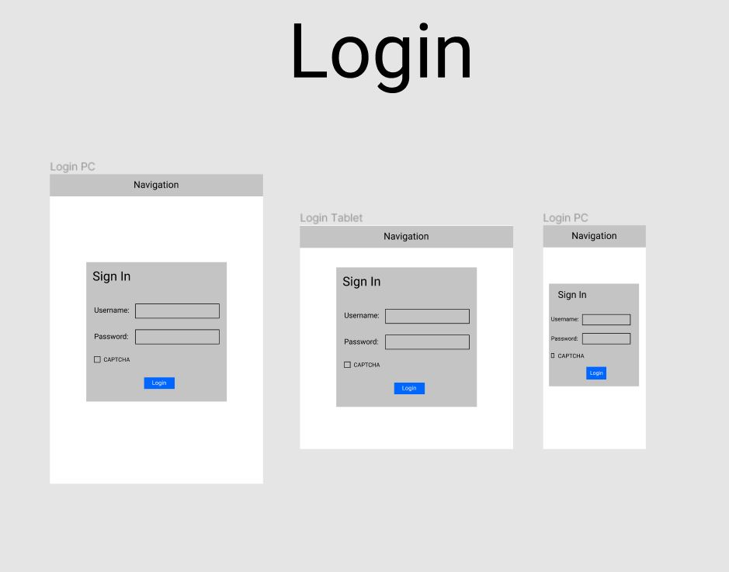

**Update Profile**

